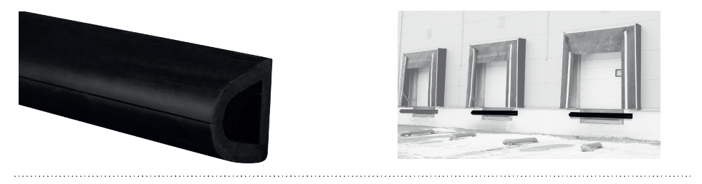


SPECIFICATION

ELASTO’PUNCH 100D
WALL PROTECTION RAIL – 100 MM HIGH
- Description: D-shaped round protection rail in non-rigid and smooth thermoplastic elastomer (Elasto’Punch 100D as manufactured by SPM) comprising a 100 mm height profile, 90 mm deep, solid colour and 14 mm thick, giving it excellent impact resistance properties and good ageing and UV resistance. Finish is provided by end pieces and screw-cover obturators in smooth thermoplastic elastomer.
- Environment: no heavy metals are used in its formulation, nor PBT/BPA. 100% of the product are recyclable.
- Colour: black.
- Installation method: by screwing.
